

Eulogio “AMANG” Rodriguez Institute of Science & Technology

# COLLEGE OF INDUSTRIAL TECHNOLOGY

Valencia St., Sampaloc, Manila

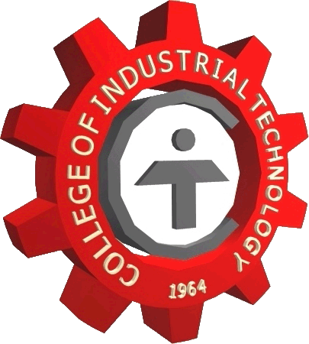

**MEMORANDUM OF AGREEMENT**

**KNOW ALL MEN BY THESE PRESENT:**

This Agreement is made entered into by and between

**PEAK MOTORS PHILIPPINES, INCORPORATED**, located at 2943 Jose Abad Santos Avenue, Tondo Manila

And

**EULOGIO “Amang” RODRIGUEZ INSTITUTE OF SCIENECE AND TECHNOLOGY** with the **COLLEGE OF INDUSTRIAL TECHNOLOGY (CIT)** a state educational institution here represented by its Dean Jojo R. Sonio ,with address at Nagtahan Sampaloc Manila, here after reffered to as the **“EARIST/CIT”**

**WITNESSETH THAT:**

PEAK MOTORS PHILIPPINES Inc.: Automotive Industry

Whereas EARIST/CIT desirous to send students to PEAK MOTORS PHILIPPINES Inc. and avail of the In-Plant Training Program

Now therefore, for inconsideration of the above premises, the parties here to agreed on the following terms of conditions.

1. EARIST/CIT shall provide the student trainees basic orientation on work values behavior, and discipline to ensure smooth cooperation with PEAK MOTORS PHILIPPINES Inc. PEAK MOTORS PHILIPPINES Inc.
2. EARIST/CIT shall issue on official endorsement letter and other pertinent training documents for the well being of the student trainee which shall be used by PEAK MOTORS PHILIPPINES Inc., for processing the application of the student trainee.
3. EARIST/CIT voluntarily withdraw the student trainee who is found to misbehave in accordance with existing policies, rules and regulation of PEAK MOTORS PHILIPPINES Inc. and impose necessary sanction to the said student trainee.
4. PEAK MOTORS PHILIPPINES Inc. shall discuss the duties and responsibilities of the student trainees before the start of training period,
5. PEAK MOTORS PHILIPPINES Inc. may grant training allowance to the students trainee in accordance with the company’s existing policies, rules and regulation,
6. PEAK MOTORS PHILIPPINES Inc. upon consultation with EARIST/CIT may require qualified students to submit themselves to examinations, interviews and file significant documents to support their application.
7. PEAK MOTORS PHILIPPINES Inc. is not obligated to employ student-trainee upon completion of training,
8. PEAK MOTORS PHILIPPINES Inc. shall not in way liable for injury, accident or death that the student trainee may suffer at any given place or venue and the student trainee shall hold PEAK MOTORS PHILIPPINES Inc. harmless and free from any liability for damage or injury to the student-trainee which may be occasioned by the international or negligence act of the student-trainee,
9. PEAK MOTORS PHILIPPINES Inc. shall be held liable for any injury ,accident or death that the student-trainee may suffer if it is proven that PEAK MOTORS PHILIPPINES Inc. has assigned the student-trainee to an unsafe working environment and has not provided the proper measures and precaution,
10. It is clearly understood that within the period of training, no employer-employee relationship exists nor shall in any manner be deemed to exist, between PEAK MOTORS PHILIPPINES Inc. and the student trainee.
11. The duration of training shall be equivalent 600 working hours unless otherwise agreed upon by PEAK MOTORS PHILIPPINES Inc. and EARIST/CIT
12. Upon the completion of In-Plant training ,the PEAK MOTORS PHILIPPINES Inc. shall provide a Certificate of training to the student trainee
13. Any violation of the foregoing covenants will warrant the cancellation of the memorandum of agreement by PEAK MOTORS PHILIPPINES Inc. within (30) days upon notice to EARIST/CIT,
14. The Memorandum of agreement shall become effective upon signature of both parties and implementation will begin immediately and shall continue to be valid hereafter until written notice is given by either party within (30) days prior to the date of intended termination.

WITNESS WHEREOF, the parties have hereunto their hands this _________day of_______________

PEAK MOTORS PHILIPPINES Inc. EARIST/ CIT

**MR. LIVI V. MARQUEZ MR. ROBERTO E. REYNOSO**

HR Consultant Training Coordinator

**MS. JENNA MARIE GARCIA DR. JOJO R. SONIO**

HR Supervisor Dean